CS4121 Assignment 3 Due: 10/16/19
- (15 Points) Consider the following TCP session between hosts A and host B on a perfect channel: A has a file of size 2.5MSS to send to B. A desires to send segments of alternating sizes MSS and MSS/2 (sequence number = 0 and ACK number = 0 for the first segment of size MSS). B also has a file of size 2.5MSS to send to A. B desires to send segments of alternating sizes MSS/2 and MSS (sequence number = 0 for the first segment of size MSS/2). A sends first.
Draw all the segment exchanges until the neither A nor B has any more bytes to send and any more bytes to acknowledge. For each segment, clearly mark the sequence number, the ACK number, and the size of data it carries.

Note:
- Nodes A and B don’t have to fully fill up their “desired” segment size if there is not sufficient bytes to send, especially at the end of their conversation, where it is even possible for them to send a segment whose data size is equal to 0.
- If the data size is equal to 0 in a segment, the sequence number field is irrelevant. You may just mark N/A.
- Upon receiving a segment with the data size equal to 0, if the host still has more data to send, it sends the next segment out and re-uses the most-recently-used ACK number. If the host has no more data to send, it just keeps silence.
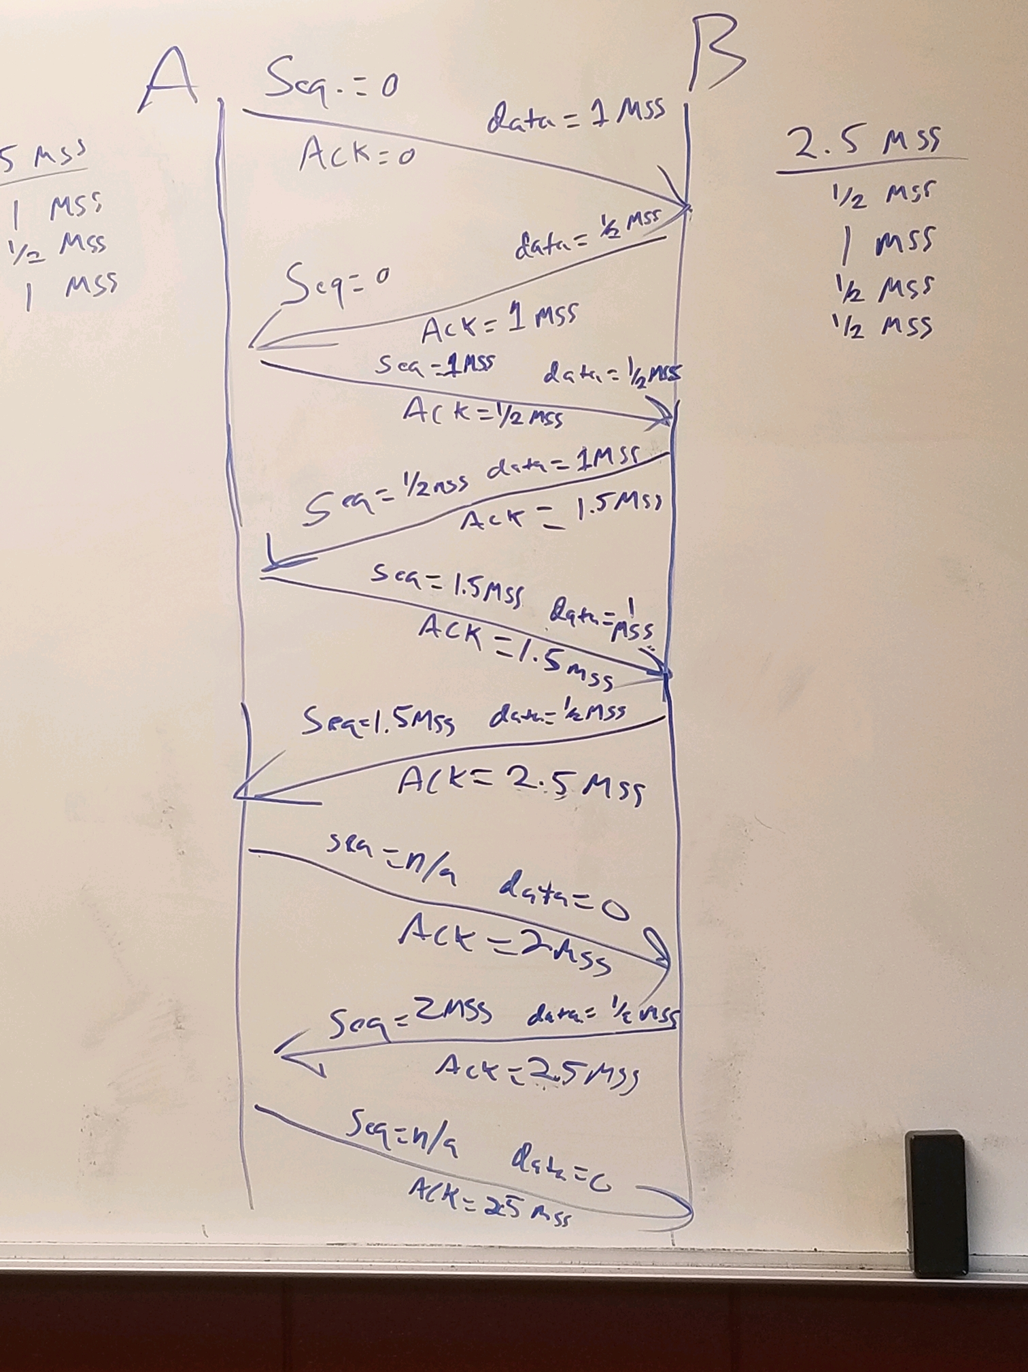
- (15 points) Assuming TCP Reno is the protocol experiencing the behavior described below.

- Initial Threshold = 36 segments
- At the transmission round that the 40th segment is sent (NOT the 40th transmission round), segment loss is detected by a timeout.
- At the 23rd transmission round, segment loss is detected by triple duplicate ACKs.
Plot the evolution of the TCP’s congestion window from the 1st through the 30th transmission round.

On the curve, mark clearly the transmission round and the congestion window size at the 1st point, the last point, and all the turning points. E.g. at the 1st point, you should mark (1,1).

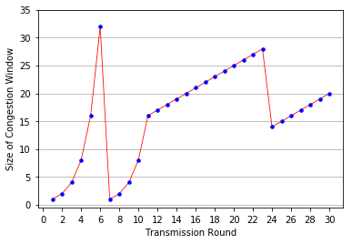
(1, 1)
(6, 32)
(23, 28)
(30, 20)
(11, 16)
(24, 14)

